SASSESSMENT TOOL 2

COURSE NAME: Computer Networks CSA07 COURSE CODE: CSA0711

COURSE OUTCOME COVERED

CO1: Apply the functions of OSI layer in enabling reliable data transmission across networks. (BL2, BL3)

Assessment Tool Weightage: 30%

1. A partially completed concept map is given below:

Application → Presentation → ______ → Transport → Network → ______ → Physical.
Analyze the missing layers and explain how their functions are essential for reliable communication.

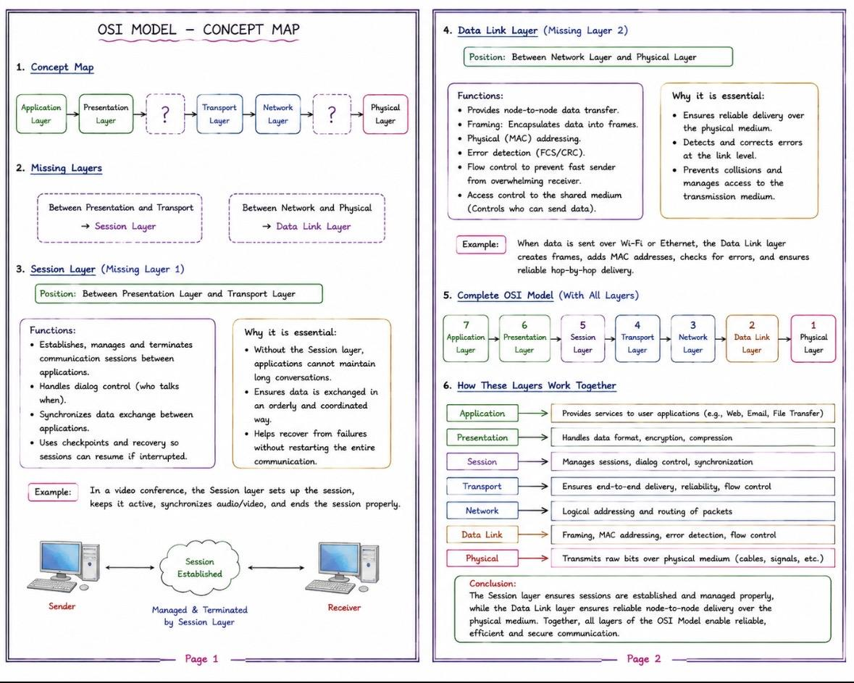

2. Construct a concept map linking data units (Segment, Packet, Frame, Bits) with their respective OSI layers and analyze how transformation of data units supports transmission.
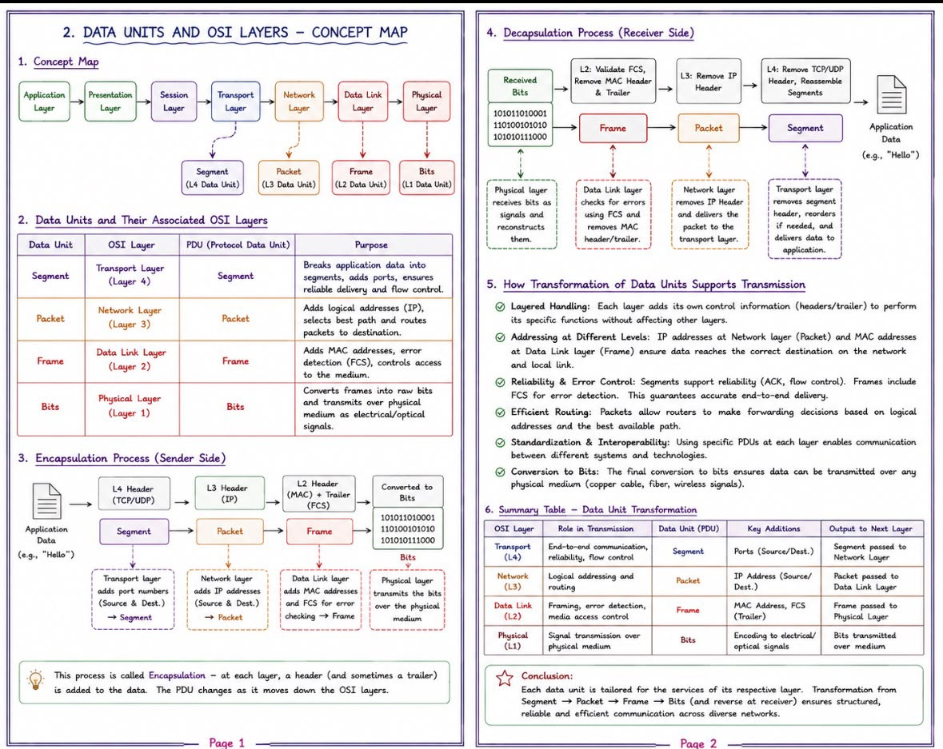

3.Given the concept map:
DataLink→MACAddress→LocalDelivery
Network → IP Address → Global Delivery
Explain how these relationships ensure complete data delivery across networks. ​​​​​​​​​​
